Colombia - Asia hospital

Objective Questions:

- In analysing the hospital dataset with Power BI, ensure data cleaning to address inconsistencies and missing values before further analysis.

Ans: Data Cleaning Performed
Before performing any analysis, the dataset was thoroughly cleaned in Power Query Editor to ensure accuracy and reliability of insights.
A. Handling Missing Values
The patient satisfaction score column contained null values.
To handle this, a department-level grouped mean imputation method was applied in Power Query.
First, the average satisfaction score was calculated for each department using Group By (Average aggregation).
Then, after merging the department-level average back into the main table, a custom column was created using the following M expression:
if [patient_sat_score] = null
then [Dept_Avg_Sat]
else [patient_sat_score]
This logic checks:
- If the original satisfaction score is null → replace it with the department’s average satisfaction score
- Otherwise → retain the original value
After this step:
- The original column was removed
- The newly generated column was renamed to patient_sat_score
This ensured that all missing satisfaction scores were replaced using department-wise averages before proceeding with analysis.
B. Data Type Corrections
Several columns were corrected to proper data types:
- Date → Date/Time (using locale to match DD-MM-YYYY HH:MM:SS format)
- Patient Age → Whole Number
- Patient Wait Time → Whole Number
- Appointment Fees & Total Bill → Decimal Number
- Patient Admin Flag → Boolean
Correct data types ensured accurate aggregations and calculations.
C. Removing Duplicates
Duplicate records were checked and removed using Remove Duplicates based on unique patient identifiers.

- Assess the Average Waiting Time: Analyse the patient wait times to identify the average duration a patient spends before receiving care.
Ans: The patient_waittime column was analysed to determine how long patients wait before receiving care. A DAX measure was created to calculate the overall average waiting time:

Average Waiting Time = AVERAGE ('Hospital ER'[patient_waittime])

The calculated average waiting time is 35.26 minutes, indicating that patients wait approximately 35 minutes on average before being attended.
Further analysis was conducted at the department level to understand operational differences across departments. Department-wise average waiting time and average patient satisfaction (PSAT) scores were calculated using aggregation measures in Power BI. This comparison helps identify departments with higher waiting times and evaluate how waiting duration relates to patient satisfaction levels.

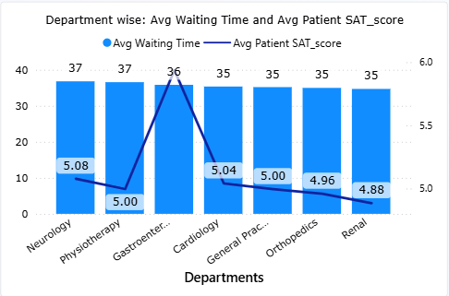
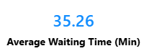

Insights
- The average waiting time across departments is fairly consistent, ranging between 35–37 minutes.
- Neurology and Physiotherapy have the highest waiting times (~37 minutes).
- Gastroenterology shows the highest patient satisfaction (~6) with slightly lower waiting time (~36 minutes).
- Orthopedics and Renal have comparatively lower satisfaction scores (<5) despite similar waiting times, indicating other factors may affect patient experience.

Recommendations
- Review patient flow and staffing in Neurology and Physiotherapy to reduce waiting time.
- Analyze practices in Gastroenterology to replicate factors contributing to higher satisfaction.
- Investigate service quality and patient interaction in Orthopedics and Renal to improve satisfaction levels.

- Visits by Department Referral: Calculate the total number of visits to each department based on referrals to understand which departments are most frequently visited.
Ans: To determine the number of patient visits per department, the Department Referral column was analyzed. A measure was created in Power BI to count the total visits for each department.
Total Visits = COUNT ('Hospital ER'[department_referral])
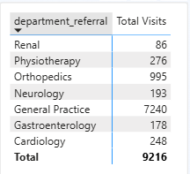
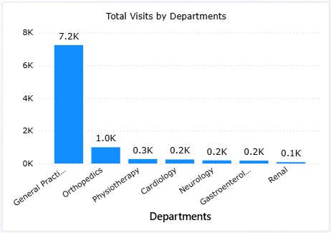

Insights
- General Practice dominates patient visits (~7.2K), accounting for the vast majority of referrals.
- Orthopedics (~1K) is the second most visited department but far behind General Practice.
- Other departments such as Physiotherapy, Cardiology, Neurology, Gastroenterology, and Renal receive comparatively very low visit volumes (100–300 visits).
- This suggests General Practice acts as the primary entry point for patients before referrals to specialized departments.

Recommendations
- The hospital should consider allocating more doctors and support staff to General Practice to handle the high patient load.
- Implementing a stronger referral and triage system can distribute patients more efficiently to specialized departments.
- Departments with lower visit volumes could be evaluated for capacity utilization or awareness programs to optimize their services.
- Monitoring patient flow from General Practice to specialized departments can help improve overall operational efficiency.

- Patient Visits by Age Group: Segregate patient visits according to different age groups to see which demographics utilize healthcare services the most.
Ans: To analyze which age demographics utilize healthcare services the most, patients were categorized into age groups using a calculated column:
Age Group = SWITCH (TRUE (),
'Hospital ER '[patient_age] <= 18, "0–18",
'Hospital ER '[patient_age] <= 35, "19–35",
'Hospital ER '[patient_age] <= 60, "36–60",
"60+"
)
The number of visits for each age group was then calculated using the Total Visits measure:
Total Visits = COUNTROWS ('Hospital ER ')

A table visualization was used with Age Group and Total Visits to analyze the distribution of visits across age groups.
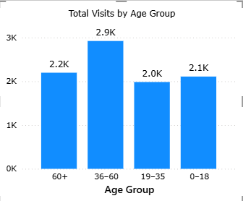
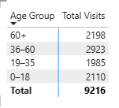

Insights
- The 36–60 age group has the highest number of visits (2923), indicating that middle-aged adults are the most frequent users of healthcare services.
- The 60+ age group also shows a high number of visits (2198), reflecting increased healthcare needs among older patients.
- The 0–18 and 19–35 age groups show relatively lower visit counts, suggesting younger populations require medical attention less frequently.

Conclusion / Recommendation
- Healthcare services appear to be primarily utilized by middle-aged and older patients.
- The hospital should ensure adequate resources and specialists for age-related conditions, especially for the 36–60 and senior (60+) demographics.
- Preventive health programs and awareness initiatives could also be targeted toward younger age groups to promote early health management.

- Were there any Null values in the data? What would be the best way to handle these Null values and which approach have you opted for?
Ans: Yes, the dataset contained null values in the patient_sat_score column.
To handle these missing values, a department-wise grouped mean imputation approach was applied instead of removing the rows, since deleting them would result in significant data loss.
First, the average satisfaction score for each department was calculated using a Group By (Average aggregation) in Power Query. This department-wise average was then merged back into the main dataset.
A custom column was created using the following logic to replace null values:
if [patient_sat_score] = null
then [Dept_Avg_Sat]
else [patient_sat_score]

This condition checks whether the satisfaction score is null. If it is null, it replaces it with the average satisfaction score of the respective department; otherwise, the original value is retained.
After this transformation, the original column was replaced with the updated column containing the imputed values, ensuring that the dataset remained complete and suitable for further analysis.

- Is there any relation between the number of visits and the Gender of the patients?
Ans: To analyze whether there is any relationship between the number of visits and patient gender, the visits were segmented using the patient_gender column.
The Total Visits measure was used to count the number of visits:
Total Visits = COUNTROWS ('Hospital ER')

A visualization was created with Patient Gender as the category and Total Visits as the value to compare the number of visits made by male and female patients.
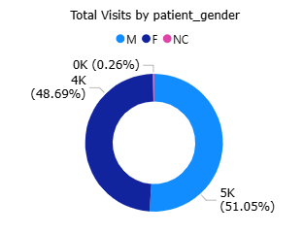

The dataset shows the following distribution of patients visiting the ER:
- Male: 5K patients (51.05%)
- Female: 4K patients (48.69%)
- Not Classified (NC): 0K patients (0.26%)
Insights

The gender distribution of ER visits is almost balanced, with males slightly higher than females. This indicates that emergency services are being utilized nearly equally by both genders, suggesting no major gender bias in ER usage.
The Not Classified category represents a very small proportion (0.26%), which indicates that the hospital’s data collection process is generally accurate, with minimal missing or unrecorded gender information.

Business Interpretation

Since ER visits are nearly equally distributed between males and females, hospital resource planning (staff allocation, treatment facilities, etc.) should not assume gender-specific demand patterns but instead focus on overall patient volume and case severity.

- Average Satisfaction by Demographics: Determine the relationship between patient satisfaction scores, their age groups, and racial backgrounds to pinpoint areas for improvement in patient experience.
Ans: Average Satisfaction by Demographics
The analysis of patient satisfaction across age groups and racial backgrounds shows that satisfaction scores are fairly consistent across all demographics, generally ranging around 4.8 to 5.2.
- Middle-aged patients show slightly higher satisfaction levels (peaking around ~5.2), indicating a relatively better service experience.
- Young adults and teenagers have moderate satisfaction, mostly around the average (~5.0), with minor variations across races.
- Senior citizens show slightly lower satisfaction in some groups (around ~4.8–4.9), indicating potential gaps in their experience.
Across racial groups, there are no major differences in satisfaction scores, as most values remain close to the overall average. This suggests that the hospital is providing a consistent and unbiased level of service across different racial backgrounds.
Approach
- Created an Age Category column in Power Query using the existing Age Group column to make the data more interpretable.
- Defined a measure Avg Satisfaction using the average of patient satisfaction scores.
- Built a Clustered Bar Chart with:
  - X-axis: Age Category
  - Y-axis: Avg Satisfaction (measure)
  - Legend: Patient Race
This setup allowed comparison of patient satisfaction across different age categories and racial groups simultaneously.
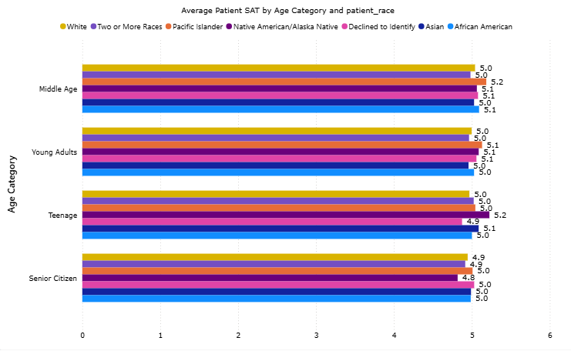

Key Insight
Patient satisfaction does not significantly vary by demographics, indicating uniform service quality. However, slight dips among senior citizens and certain groups highlight areas where targeted improvements can enhance overall experience.
Recommendation
- Improve service experience for senior citizens, focusing on comfort and assistance
- Maintain consistent service quality across all racial groups
- Focus on operational improvements (like wait time and patient handling) to further increase satisfaction levels overall

- The hospital's managing director seeks to evaluate the revenue of each department to understand how much revenue is generated by each.
Ans: Approach

A clustered column chart was created with:

X-axis: department_referral
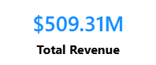
Y-axis: Total Revenue (Measure)

Total Revenue = SUM ('Doctor-Patients Data'[Total Bill])

to analyse revenue contribution across departments.

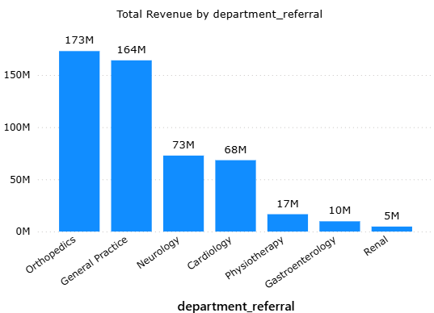

Insights

Orthopedics (173M) and General Practice (164M) generate the highest revenue, contributing a major share of the total 509.31M.
Neurology (73M) and Cardiology (68M) form the mid-tier contributors.
Physiotherapy (17M), Gastroenterology (10M), and Renal (5M) generate significantly lower revenue.
Revenue is highly concentrated in a few departments, indicating uneven contribution.

- Which department is charging the highest appointment fees in general? Use an aggregation DAX function to solve this question.
Ans: Approach
A DAX measure was created to find the highest appointment fee:
Max Appointment Fee = MAX ('Doctor-Patients Data'[Appointment Fees])

A bar chart was used with:
- Axis: department_referral
- Values: Max Appointment Fee
to compare the maximum fees charged across departments.
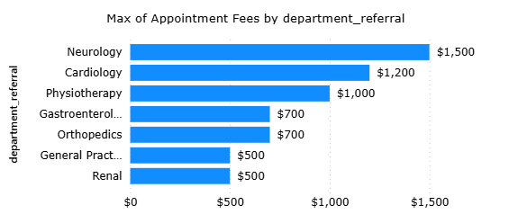
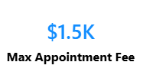

Insights

- Neurology charges the highest appointment fee ($1,500) among all departments.
- Cardiology ($1,200) and Physiotherapy ($1,000) also have relatively high fees.
- Departments like General Practice and Renal ($500) have the lowest maximum fees.
- There is a significant variation in pricing across departments, indicating differences in specialization and service complexity.

- Create a tabular visualization in the Report view which consists of Month-wise total visits in the hospital. Add a third column in the table that consists of the previous month’s total visits for each month’s row. Also, include a column that states whether the visits in a month are greater than that of the previous month's visits.
Ans: Approach
- Created a Calendar table using the patient visit date range
- Established relationship between Calendar and Hospital ER (Date)
- Used Calendar fields (Year, Month) for proper time-based grouping
- Applied DAX time intelligence functions to compare current vs previous month visits
- Built a table visual to track monthly trends and changes in visits

DAX Formulas
- Total Visits (Measure – Hospital ER)
Total Visits = COUNT ('Hospital ER'[patient_id])
- Previous Month Visits (Measure – Hospital ER)
Prev Month Visits = CALCULATE (
[Total Visits],
DATEADD('Calendar_Clean'[Date], -1, MONTH)
)
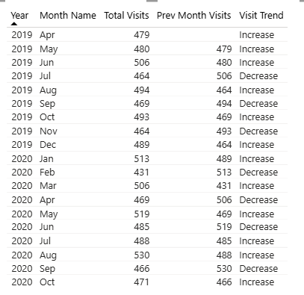
- Visit Trend (Measure – Hospital ER)
Visit Trend = SWITCH( TRUE(),
[Total Visits] > [Prev Month Visits], "Increase",
[Total Visits] < [Prev Month Visits], "Decrease",
"No Change"
)

Insights
- Visits fluctuate month-to-month with no steady pattern
- Highest visits observed in Aug 2020, lowest in Feb 2020
- Frequent increases followed by drops indicate unstable demand
- Overall trend shows slight growth with variability

Conclusion
Patient inflow is inconsistent, suggesting need for better monthly planning and resource allocation.

- Using ‘Calculate’ and a row iteration DAX function calculate the total number of patients who have visited Dr. Smith.
Ans: To calculate the total number of patients who have visited Dr. Smith using CALCULATE, I created a measure as mentioned below:
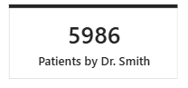
Patients by Dr. Smith =
CALCULATE (
DISTINCTCOUNT ('Doctor-Patients Data'[patient_id]),
FILTER (
'Doctor-Patients Data',
'Doctor-Patients Data'[Doctor Name] = "Dr. Smith"
)
)
By using CALCULATE in combination with a row-level iteration function (FILTER), I filtered the dataset to include only rows where Doctor Name = Dr. Smith. Then, I applied DISTINCTCOUNT on patient_id to count unique patients.
This resulted in a total of 5,986 patients who visited Dr. Smith.
This calculation provides insight into Dr. Smith’s patient load, helping analyze workload and patient distribution across doctors.
Fact: Dr. Smith has treated the highest number of patients among all doctors.

- Calculate the average age of the patients who visit the Orthopedics department. Will the approach used to calculate this metric be different if the requirement had been all departments’ average age?
Ans: To calculate the average age of patients visiting the Orthopaedics department using CALCULATE, I created a measure as mentioned below:
Avg Age Orthopedics =
CALCULATE(
AVERAGE('Hospital ER'[patient_age]),
'Hospital ER'[department_referral] = "Orthopedics"
)
By using CALCULATE, I filtered the dataset to include only rows where Department Referral = Orthopedics. Then, I applied AVERAGE on patient_age to compute the average age of patients.
This provides insight into the typical age group visiting the Orthopedics department.

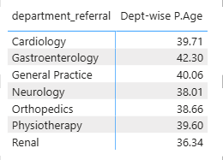

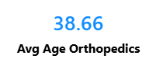

For all departments:
For all departments, the same approach can be extended by creating an overall average age measure and using a Matrix visual with Department Referral as rows. This will automatically display the average age for each department.

Avg Age All = AVERAGE ('Hospital ER'[patient_age])

- Were there any data format issues in the data, and if there were/are how you handle them?
Ans: Steps Taken to Resolve Data Format Issues:
- Combining Columns for Patient Name:
- The patient_first_initial and patient_last_name columns were stored separately, making it inconvenient for analysis.
- Using Power Query, I merged these columns into a single patient_name column, ensuring proper formatting for better usability in queries and reports.

- Extracting Dates,Times and Creating a Calendar Table:
- The date column included both date and time, but only the date component was needed for analysis.
- I created a custom column to extract the date and generated a calendar table to enable advanced date-based filtering and trend analysis.

- Handling Blank Spaces in Scores:
- The patient_sat_scores column had blank spaces, which could disrupt calculations and analysis.
- Initially, the data type of patient_sat_scores was in text format, so I converted it to a number.
- After conversion, I replaced the blank spaces (null values) with the column's mean value, ensuring data consistency and avoiding skewed results during computations.

- Result: The dataset was transformed into a clean and consistent format, making it ready for reliable analysis and accurate insights.

- When we add a column in Power Query what’s the code that comes in M language in the formula bar? What do you know about M-query?
Ans: When we add a column in Power Query, the following type of M language code appears in
the formula bar:
= Table.AddColumn(PreviousStepName, "New Column Name", each [Column1]
+[Column2])

Explanation (M-Query)
- M Query (Power Query Formula Language) is a functional language used in Power BI for data transformation and cleaning.
- It works step-by-step, where each step is applied sequentially to transform the data.
- Every action performed in Power Query (like filtering, changing type, adding column) generates M code.
- It is case-sensitive and follows a structured syntax.
- M Query helps in ETL (Extract, Transform, Load) process before loading data into the model.

- Identify the top 5 doctors who generated the most revenue but had the fewest patients. (SQL)
Ans: Approach
To identify the top 5 doctors who generated the most revenue but had the fewest patients, I used aggregation functions on the doctor-level data.
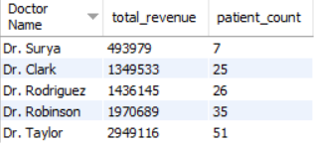
SELECT
`Doctor Name`,
SUM(`Total Bill`) AS total_revenue,
COUNT(DISTINCT patient_id) AS patient_count
FROM doctor_pateints_data
GROUP BY `Doctor Name`
ORDER BY patient_count ASC,total_revenue DESC
LIMIT 5;

Steps
- Used SUM(Total Bill) to calculate total revenue generated by each doctor .
- Used COUNT(DISTINCT patient_id) to count unique patients treated .
- Grouped the data by Doctor Name .
- Sorted results by:
  - Revenue (descending) → highest earners first
  - Patient count (ascending) → fewer patients prioritized
- Selected top 5 doctors using LIMIT.

Insights
- Doctors like Dr. Taylor and Dr. Robinson generate very high revenue despite handling relatively fewer patients
- This indicates:
  - Higher-value treatments or procedures
  - Better revenue efficiency per patient
These doctors are high-value contributors to the hospital and may be specializing in premium or critical care services.

- Find the department where the average waiting time has decreased over three consecutive months. (SQL)
Ans: Approach
To identify improvement in hospital efficiency, I analyzed the average waiting time across three consecutive months (with actual month-year values) and checked whether the waiting time consistently decreased over time for each department.

Steps
- Compared three consecutive months using:
  - prev2_month → prev1_month → current_month
  - Along with their respective waiting times
- Checked condition:
  - prev2_avg_wait > prev1_avg_wait > avg_wait
- Identified all such 3-month sequences for each department .
- Counted how frequently each department shows this decreasing trend .
- Evaluated both frequency (consistency) and magnitude (drop in values) .
WITH monthly_avg AS ( SELECT department_referral,
DATE_FORMAT(STR_TO_DATE(date, '%d-%m-%Y'), '%Y-%m') AS month,
AVG(patient_waittime) AS avg_wait
FROM hospital_er
GROUP BY department_referral, month
),
lagged AS ( SELECT department_referral, month, avg_wait,
LAG(avg_wait,1) OVER (PARTITION BY department_referral ORDER BY month) AS prev1_avg_wait,
LAG(avg_wait,2) OVER (PARTITION BY department_referral ORDER BY month) AS prev2_avg_wait,
LAG(month,1) OVER (PARTITION BY department_referral ORDER BY month) AS prev1_month,
LAG(month,2) OVER (PARTITION BY department_referral ORDER BY month) AS prev2_month
FROM monthly_avg
)
SELECT department_referral, prev2_month, prev1_month, month AS current_month,
prev2_avg_wait,
prev1_avg_wait,
avg_wait
FROM lagged
WHERE avg_wait < prev1_avg_wait
AND prev1_avg_wait < prev2_avg_wait;

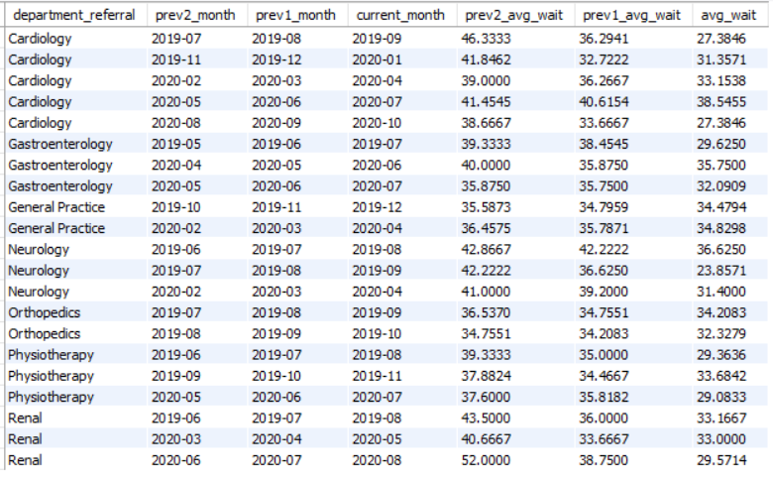
Insights

- Cardiology shows the highest consistency with 5 decreasing trends .
  - Example: 2019-07 → 2019-09 (46.33 → 27.38) → significant drop
- Gastroenterology shows 3 improvement periods, with moderate reductions
- Neurology shows high-impact improvements, especially .
  - 2019-07 → 2019-09 (42.22 → 23.85) → very sharp decline
- Renal also shows strong improvements .
  - 2020-06 → 2020-08 (52.00 → 29.57) → largest drop observed
- Physiotherapy and Orthopedics show steady but gradual improvements .
- General Practice shows minimal change, indicating relatively stable waiting times .

Conclusion
Cardiology is the most consistently improving department, while Neurology and Renal demonstrate the most significant reductions in waiting time. Other departments show gradual improvements, indicating overall positive operational trends across the hospital.

- Determine the ratio of male to female patients for each doctor and rank the doctors based on this ratio. (SQL)
Ans: Approach

To analyze gender distribution across doctors, I calculated the number of male and female patients for each doctor, derived the male-to-female ratio, and ranked doctors based on this ratio.
SELECT
dp.`Doctor Name`,
SUM(CASE WHEN he.patient_gender = 'M' THEN 1 ELSE 0 END) AS male_count,
SUM(CASE WHEN he.patient_gender = 'F' THEN 1 ELSE 0 END) AS female_count,
SUM(CASE WHEN he.patient_gender = 'M' THEN 1 ELSE 0 END) /
NULLIF(SUM(CASE WHEN he.patient_gender = 'F' THEN 1 ELSE 0 END), 0) AS male_female_ratio,
RANK() OVER (
ORDER BY
SUM(CASE WHEN he.patient_gender = 'M' THEN 1 ELSE 0 END) /
NULLIF(SUM(CASE WHEN he.patient_gender = 'F' THEN 1 ELSE 0 END), 0) DESC
) AS rank_doctor
FROM doctor_pateints_data dp
JOIN hospital_er he ON dp.patient_id = he.patient_id
GROUP BY dp.`Doctor Name`;

Steps
- Counted total male patients and female patients for each doctor .
- Calculated male_female_ratio as male_count divided by female_count .
- Ranked doctors in descending order of the ratio .
- Compared both counts and ratios to understand actual distribution .
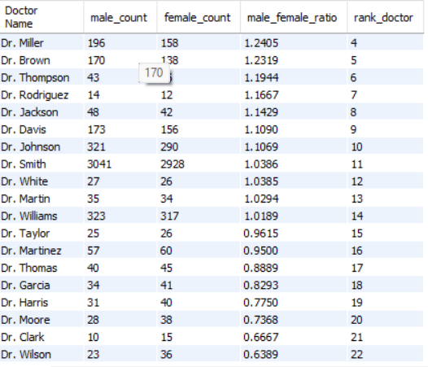

Insight
Doctors such as Dr. Miller (ratio 1.24) and Dr. Brown (1.23) have a higher proportion of male patients, indicating a noticeable gender skew toward male patients.
Doctors like Dr. Smith (1.03) and Dr. Johnson (1.10) show a more balanced gender distribution with large patient volumes, suggesting consistent service across both genders.
On the lower end, doctors such as Dr. Wilson (0.63), Dr. Clark (0.66), and Dr. Moore (0.73) have significantly more female patients compared to male patients.
Overall, most doctors have ratios close to 1, indicating relatively balanced gender distribution, with a few exceptions showing strong gender preference patterns.

- Calculate the average satisfaction score of patients for each doctor based on their visits. (SQL)
Ans: Approach
To evaluate patient experience across doctors, I calculated the average satisfaction score per doctor, handling missing values by assigning a neutral score and then comparing the results.

Steps
- Joined hospital and doctor tables using patient_id
- Replaced blank/null satisfaction scores with a default value (5) ..
- Converted scores into numeric format and calculated average satisfaction per doctor .
- Rounded values for better readability .
- Sorted doctors in descending order of satisfaction score .
SELECT
d.`Doctor Name`,
ROUND(AVG(CASE
WHEN h.patient_sat_score = '' OR h.patient_sat_score IS NULL THEN 5
ELSE CAST(h.patient_sat_score AS DECIMAL(5,2))
END), 2
) AS avg_satisfaction_score
FROM hospital_er h
INNER JOIN doctor_pateints_data d
ON d.patient_id = h.patient_id
GROUP BY d.`Doctor Name`
ORDER BY avg_satisfaction_score DESC;

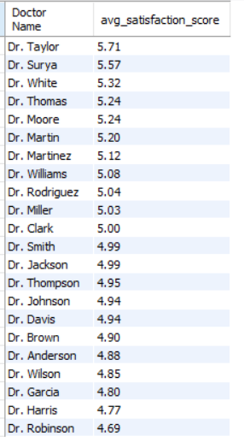
Insights
- Dr. Taylor (5.71) and Dr. Surya (5.57) have the highest satisfaction scores, indicating strong patient experience and service quality.
- Doctors like Dr. White, Dr. Thomas, and Dr. Moore (~5.2–5.3) also perform consistently well.
- Most doctors fall in a narrow range of ~4.8 to 5.7, indicating overall stable satisfaction levels across the hospital.
- Dr. Robinson (4.69), Dr. Harris (4.77), and Dr. Garcia (4.80) are on the lower end, suggesting potential areas for improvement.
- High-volume doctors like Dr. Smith (4.99) and Dr. Johnson (4.94) maintain near-average satisfaction, indicating balanced performance under workload.

Conclusion
Overall patient satisfaction is relatively consistent across doctors, with a few top performers standing out. The hospital can analyze high-performing doctors to replicate best practices and improve satisfaction for lower-performing ones.

- Find doctors who have treated patients from different races and calculate the diversity of their patient base. (SQL)
Ans: Approach
To evaluate diversity in patient base, I analyzed the number of unique races treated by each doctor and compared it with their total patient count using a diversity ratio.

Steps
- Counted distinct patient races treated by each doctor .
- Counted total unique patients per doctor .
- Calculated diversity_ratio as unique_races divided by total_patients .
- Filtered doctors treating patients from more than one race .
- Sorted doctors based on diversity ratio in descending order .
SELECT
d.`Doctor Name`,
COUNT(DISTINCT h.patient_race) AS unique_races,
COUNT(DISTINCT h.patient_id) AS total_patients,
ROUND(
COUNT(DISTINCT h.patient_race) / COUNT(DISTINCT h.patient_id), 4
) AS diversity_ratio
FROM hospital_er h
INNER JOIN doctor_pateints_data d
ON h.patient_id = d.patient_id
GROUP BY d.`Doctor Name`
HAVING COUNT(DISTINCT h.patient_race) > 1
ORDER BY diversity_ratio DESC;

Insights
- Dr. Surya (0.57) shows the highest diversity ratio, treating 4 races across only 7 patients, indicating a highly diverse but very small patient base.
- Doctors like Dr. Clark (0.24) and Dr. Rodriguez (0.19) also show relatively high diversity with moderate patient counts.
- Many doctors (e.g., Dr. Taylor, Dr. White, Dr. Wilson) treat patients from all 7 races, showing complete coverage across race categories.
- However, as patient count increases, the diversity ratio decreases, even if all races are covered.
- High-volume doctors like Dr. Smith (5986 patients), Dr. Williams, and Dr. Johnson have very low ratios because the denominator is very large.

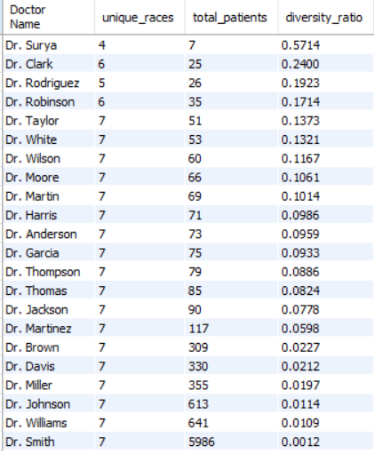
Conclusion
Doctors with smaller patient bases show higher diversity ratios, while high-volume doctors demonstrate broader real-world diversity by covering all race categories. Therefore, both unique race count and patient volume should be considered together for accurate interpretation of diversity.

- Calculate the ratio of total bills generated by male patients to female patients for each department. (SQL)
Ans: Approach
To understand revenue contribution by gender across departments, I calculated total revenue generated by male and female patients separately and derived their ratio for each department.

Steps
- Aggregated total bill separately for male and female patients for each department .
- Calculated male_female_revenue_ratio as male_revenue divided by female_revenue .
- Compared both absolute revenue values and ratios across departments .
- Identified departments with higher contribution from each gender .

SELECT
d.department_referral,
SUM(CASE WHEN h.patient_gender = 'M' THEN d.`Total Bill` ELSE 0 END) AS male_revenue,
SUM(CASE WHEN h.patient_gender = 'F' THEN d.`Total Bill` ELSE 0 END) AS female_revenue,
ROUND(
SUM(CASE WHEN h.patient_gender = 'M' THEN d.`Total Bill` ELSE 0 END) /
NULLIF(SUM(CASE WHEN h.patient_gender = 'F' THEN d.`Total Bill` ELSE 0 END), 0), 4) AS male_female_revenue_ratio
FROM doctor_pateints_data d
JOIN hospital_er h
ON d.patient_id = h.patient_id
GROUP BY d.department_referral;

Insight

- Orthopedics (1.19) shows the highest male-to-female revenue ratio, indicating significantly higher revenue contribution from male patients .
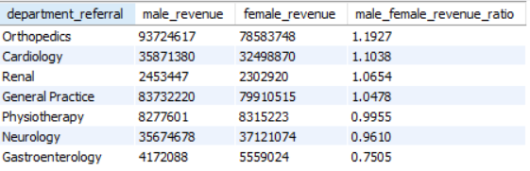
- Cardiology (1.10), Renal (1.06), and General Practice (1.04) also show higher male contribution, but the difference is moderate .
- Physiotherapy (0.99) is almost balanced, with nearly equal contribution from both genders.
- Neurology (0.96) shows slightly higher revenue from female patients .
- Gastroenterology (0.75) has a strong female dominance in revenue contribution .

Conclusion
Male patients contribute more revenue in most departments, especially Orthopedics, while Gastroenterology and Neurology show higher female contribution. Overall, the hospital shows a relatively balanced gender-based revenue distribution with some department-specific variations.

- Update the patient satisfaction score for all patients who visited the "General Practice" department and had a waiting time of more than 30 minutes. Increase their satisfaction score by 2 points, but ensure that the satisfaction score does not exceed 10. (SQL)
Ans: Approach
Updated patient satisfaction scores for patients in the General Practice department with waiting time greater than 30 minutes, ensuring values were increased while handling blanks and maintaining the upper limit.

SET SQL_SAFE_UPDATES = 0;
UPDATE hospital_er
SET patient_sat_score =
LEAST(CASE
WHEN patient_sat_score = '' OR patient_sat_score IS NULL THEN 2
ELSE CAST(patient_sat_score AS SIGNED) + 2
END,10)
WHERE department_referral = 'General Practice'
AND patient_waittime > 30;
SET SQL_SAFE_UPDATES = 1;

Steps
- Filtered rows where department is General Practice and waiting time exceeds 30 minutes .
- Handled blank/null satisfaction scores using CASE logic .
- Increased satisfaction score by 2 for valid values .
- Used LEAST function to cap the maximum value at 10 .
- Updated records directly in the table .
Insights
- 4296 rows matched the condition, out of which 4196 rows were updated .
- Some rows were not changed because their values were already at maximum (10) or resulted in no change after applying the logic .
- This update improves satisfaction scores for patients who experienced longer waiting times, simulating a corrective business action .
Conclusion
This step demonstrates how business rules can be applied directly on data to improve customer satisfaction metrics while ensuring data integrity and constraints are maintained.

Subjective Questions:
- What is the relation between patient wait time and satisfaction scores?
Ans: Approach
Used a scatter plot and line chart to visually analyse the relationship between patient wait time and satisfaction scores, and calculated the correlation measure to quantify the relationship.

Steps
- Plotted patient_waittime (min) on X-axis and Average Patient SAT on Y-axis
- Used patient_id in Details to ensure each point represents individual observation ..
- Added a line chart to observe trends across wait times .
- Created a correlation measure, which resulted in -0.01 .
Correlation =
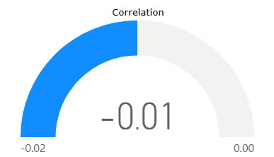
VAR AvgX = [Average Waiting Time]
VAR AvgY = [Average Patient SAT]

VAR Numerator =
SUMX(
'Hospital ER',
('Hospital ER'[patient_waittime (min)] - AvgX) *
('Hospital ER'[patient_sat_score] - AvgY)
)

VAR Denominator =
SQRT(
SUMX('Hospital ER', ('Hospital ER'[patient_waittime (min)] - AvgX)^2) *
SUMX('Hospital ER', ('Hospital ER'[patient_sat_score] - AvgY)^2)
)

RETURN
DIVIDE(Numerator, Denominator)

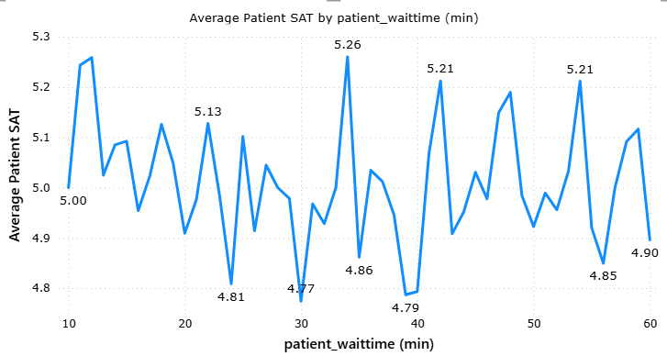

Insights
- The scatter plot shows no clear upward or downward pattern → points are randomly distributed .
- The line chart fluctuates without any consistent trend .
- Satisfaction scores remain mostly around ~4.8 to 5.3 across all wait times .
- The correlation value (-0.01) indicates an almost zero relationship between wait time and satisfaction.

Conclusion
There is no significant relationship between patient wait time and satisfaction scores in this dataset.
This suggests that factors other than waiting time (such as doctor interaction, treatment quality, or service experience) may have a greater impact on patient satisfaction.

- How do patient demographics affect the frequency of visits to different departments?
Ans: Approach
Analyzed demographic impact using stacked charts + matrix, focusing on absolute visit counts across departments by Age Group.

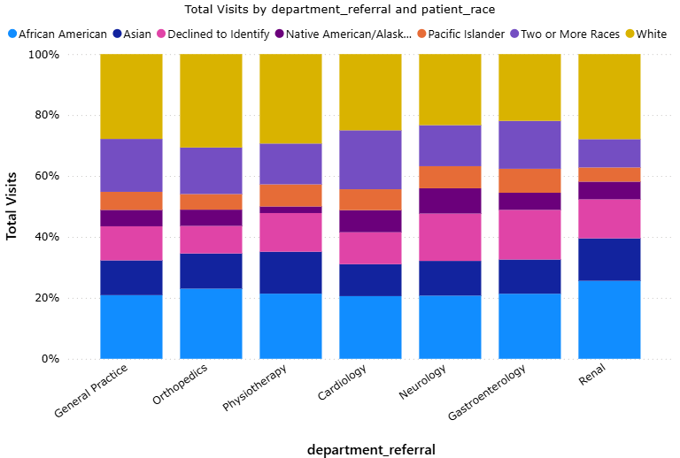
Steps
- Used stacked column charts for pattern view.
- Used matrix (department vs Age Group) for exact values .
- Compared both proportion (chart) and actual counts (matrix) .

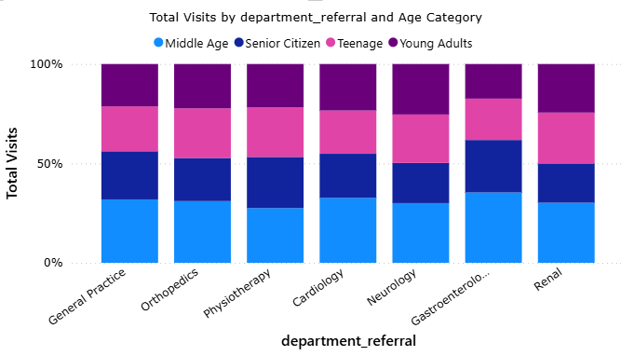
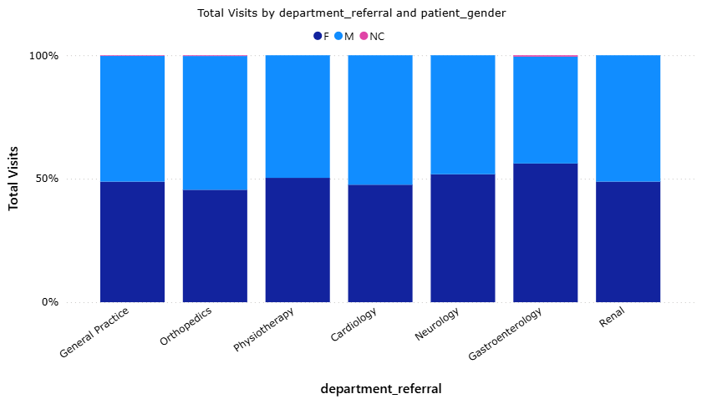
Insights
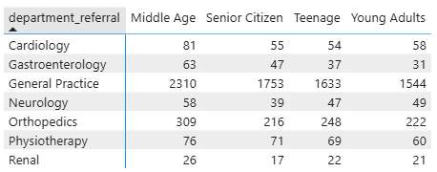
🔹 Age Group (strongest impact)
- General Practice dominates across all age groups
  - Extremely high visits:
    - Middle Age → 2310
    - Senior Citizens → 1753
    - Young Adults → 1544
- This clearly shows General Practice is the primary entry point for all demographics
- Orthopedics is the second most visited department
  - High across all age groups, especially:
    - Middle Age → 309
    - Young Adults → 222
- Teenagers consistently have lower visits
  - Across almost all departments → lowest engagement segment
- Senior Citizens show higher presence in critical departments
  - Cardiology → 55
  - Neurology → 39
→ Indicates age-related medical needs

🔹 Gender
- Distribution is nearly balanced across all departments
- No department shows strong dominance of either gender
→ Gender has minimal impact on visit frequency

🔹 Race
- While some variation exists, no department is dominated by a specific race
- Distribution is relatively even across departments
→ No strong demographic skew observed

Conclusion
Age group significantly influences department visits, with General Practice acting as the central hub for all demographics and Orthopedics as a key secondary department.
Gender and race do not show strong influence, indicating fairly uniform access and utilization across these demographics.

- Is there a noticeable trend in the volume of patient visits throughout the year?
Ans: Approach
Analyzed patient visit trends using both:
- Month-wise line chart (to observe intra-year trend)
- Year-wise trend chart (to validate overall yearly change)

Steps
- Used Month-Year vs Total Visits line chart to observe monthly movement .
- Used Year vs Total Visits chart to compare overall yearly performance .
- Cross-verified whether monthly pattern aligns with yearly trend .

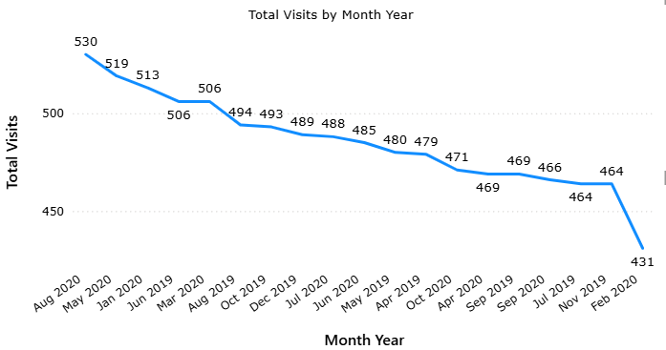
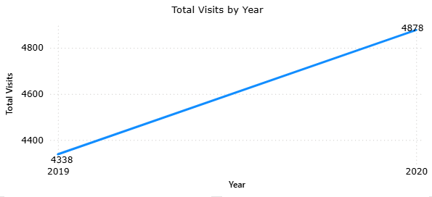

Insights
- Monthly trend shows a consistent decline in visits over time
  - From ~530 down to ~431
- The decline is gradual and steady, not seasonal
- Year-wise analysis confirms overall growth:
  - 2019 → 4338 visits
  - 2020 → 4878 visits
- This indicates:
  - While overall yearly visits increased,
  - The later months show a declining pattern

Conclusion
There is no seasonal trend, but a declining pattern within months, while overall yearly visits have increased. This suggests that although total yearly performance improved, recent months show a slowdown in patient inflow, which may require attention.

- Which age groups report the highest and lowest satisfaction scores?
Ans: Approach
Analyzed satisfaction scores across age groups using a clustered column chart and validated exact values using a matrix.

Steps
- Used Age Group on X-axis and Average Patient SAT on Y-axis .
- Enabled data labels (with decimals) for accurate comparison .
- Cross-checked values using matrix visual .
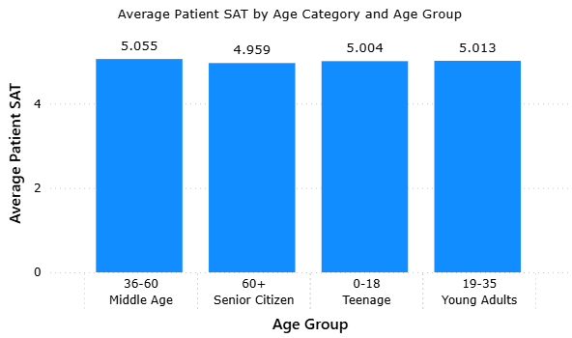
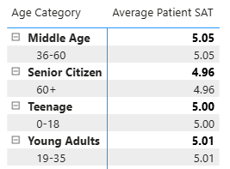

Insights
- Highest Satisfaction → Middle Age (36–60) ≈ 5.05
- Lowest Satisfaction → Senior Citizens (60+) ≈ 4.96
- Other groups:
  - Young Adults (19–35) ≈ 5.01
  - Teenagers (0–18) ≈ 5.00
- The difference between highest and lowest is very small (~0.09)
- Satisfaction scores across all age groups are very close (~5 range)

Conclusion
All age groups report almost similar satisfaction levels, with only a slight variation, where middle-aged patients are marginally more satisfied and senior citizens slightly less. This indicates a consistent patient experience across age demographics.

- Say someone outside of the hospital claims that there is racial or gender-based discrimination in the hospital, how will you identify whether the claim was right or not?
Ans: Approach
Analyzed discrimination using combined chart + separate visuals + matrix to evaluate:
- Access → Total Visits
- Treatment → Avg Waiting Time
- Experience → Avg Satisfaction Score

Steps
- Used combined chart (race + gender vs wait time & satisfaction)
- Used separate charts for race-wise and gender-wise comparison
- Validated with matrix (exact values)
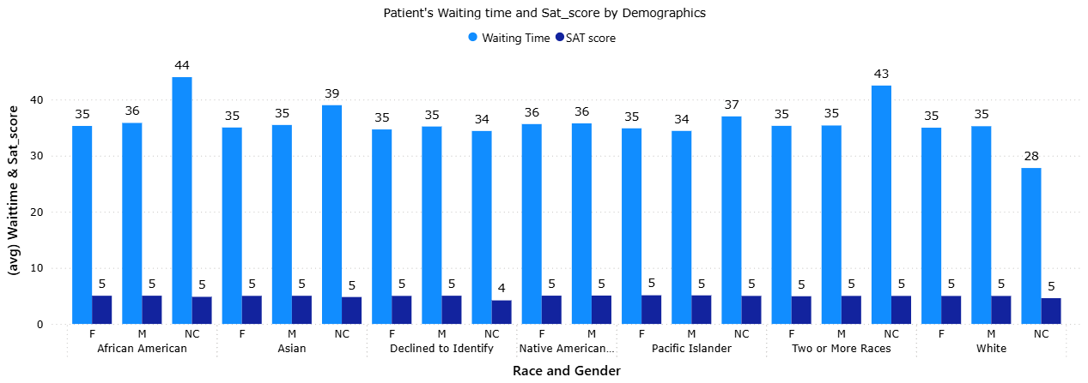

Insights

Gender Analysis
- Visits: Male and Female have almost equal and very high visit counts
- Waiting Time:
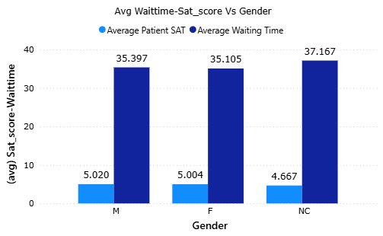
  - Male → ~35.39
  - Female → ~35.10
  - Very small difference

- Satisfaction:
  - Male → ~5.02
  - Female → ~5.00
  - Almost identical

- NC category:
  - Very low visits (negligible sample size)
  - Slightly lower satisfaction (~4.67) and higher wait (~37)
→ Not reliable for conclusion

Race Analysis

- Waiting Time:
  - Ranges narrowly between ~34.6 to ~35.7 mins
  - No race consistently higher

- Satisfaction:
  - All races fall between ~4.97 to ~5.10
  - Differences are very minimal (~0.1 range)

- Visits:
  - White, African American, and Asian have higher counts
  - But distribution exists across all races
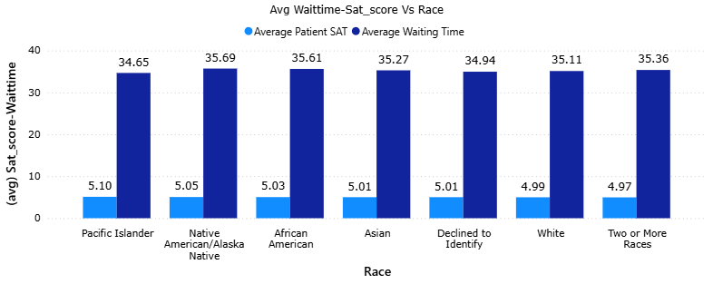
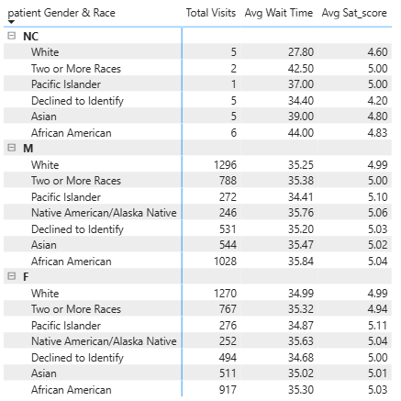

Matrix Validation

- Confirms:
  - No race/gender has consistently higher wait time .

  - No group has consistently lower satisfaction .

  - Differences are statistically very small .

Conclusion

There is no strong evidence of racial or gender-based discrimination in the hospital.
All demographic groups receive similar levels of service in terms of waiting time and satisfaction, and visit distribution is also fairly balanced.
Minor variations exist but are too small to indicate any systematic bias.

- The hospital management intends to offer discounts to patients. How should these offers/discounts be assigned to patients, on what basis, and why?
Ans: Approach
Segmented patients based on waiting time, satisfaction score, and total bill to design a targeted discount strategy. Then analyzed each segment using aggregated visuals (matrix + charts) to validate differences in experience and revenue contribution.

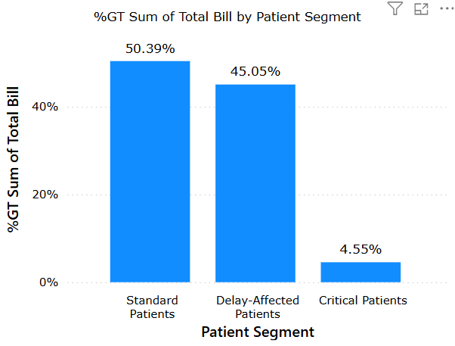
Steps (Formulas Used)

1. Patient Segment
- Type → Calculated Column
- Table → Doctor-Patients Data
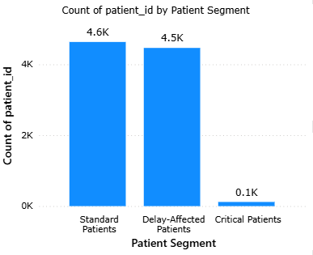
Patient Segment =
VAR AvgWait = CALCULATE(
AVERAGE('Hospital ER'[patient_waittime (min)]),
ALL('Hospital ER')
)
VAR AvgBill = CALCULATE(
AVERAGE('Doctor-Patients Data'[Total Bill]),
ALL('Doctor-Patients Data')
)
VAR WaitTime = RELATED('Hospital ER'[patient_waittime (min)])
VAR SatScore = RELATED('Hospital ER'[patient_sat_score])
RETURN
SWITCH(
TRUE(),
WaitTime > AvgWait && SatScore < 5 && 'Doctor-Patients Data'[Total Bill] > AvgBill,
"Critical Patients",
WaitTime > AvgWait,
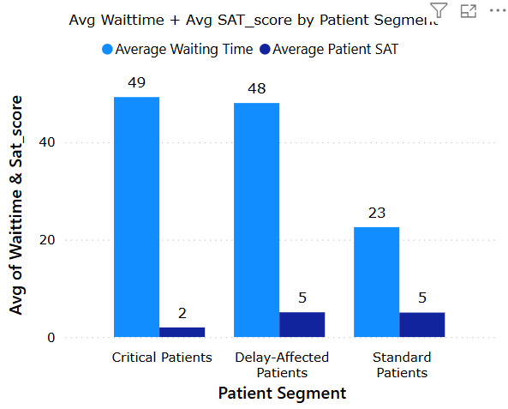
"Delay-Affected Patients",
"Standard Patients"
)

2. Discount %
- Type → Calculated Column
- Table → Doctor-Patients Data
Discount % =
SWITCH(
'Doctor-Patients Data'[Patient Segment],
"Critical Patients", 25,
"Delay-Affected Patients", 10,
"Standard Patients", 5
)
Insights / Observations
- Critical Patients
  - Highest waiting time (~49 mins)
  - Very low satisfaction (~1.97)
  - Very small group (~118 patients)
  - Low revenue contribution (~4.55%)
- Delay-Affected Patients
  - High waiting time (~48 mins)
  - Normal satisfaction (~5.08)
  - Large group (~4465 patients)
  - Significant revenue contribution (~45%)
- Standard Patients
  - Low waiting time (~22 mins)
  - Stable satisfaction (~5.02)
  - Largest group (~4633 patients)
  - Highest revenue contribution (~50%)
- Overall:
  - Waiting time is the key factor impacting segmentation
  - Majority of revenue comes from Standard + Delay-Affected patients (~95%)
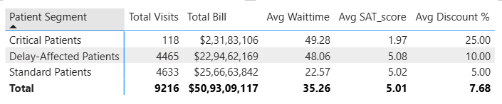

Conclusion / Recommendation
- Apply 25% discount to Critical Patients to recover poor experience and prevent churn
- Apply 10% discount to Delay-Affected Patients to improve satisfaction in a high-impact segment
- Apply 5% discount to Standard Patients to maintain loyalty without affecting revenue significantly
This strategy ensures:
- Improvement in patient experience
- Retention of high-value segments
- Balanced impact on revenue

- The hospital has a budget to hire 2-3 new doctors. They have asked for your suggestions on which departments they should hire.
Ans: Approach
Analyzed hiring requirements using department-wise demand (Total Visits), operational pressure (Average Waiting Time), patient experience (Satisfaction), and doctor workload distribution through combo chart, top-N doctor chart, and heatmap matrix.

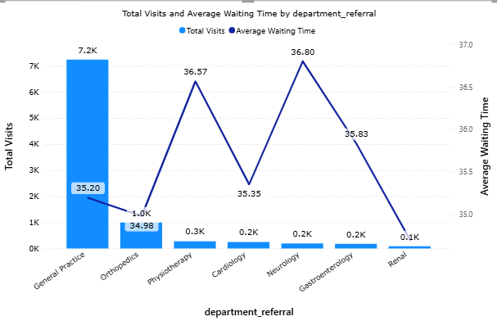
Steps (Visuals Used)
- Combo Chart
  - X → department_referral
  - Column → Total Visits
  - Line → Average Waiting Time
- Top 5 Doctors Chart
  - X → Doctor Name
  - Y → Total Visits
- Heatmap Matrix
  - Rows → department_referral
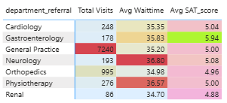
  - Values →
    - Total Visits
    - Average Waiting Time
    - Average Patient SAT
  - Conditional formatting applied

Insights / Observations
1. Demand Analysis (Total Visits)
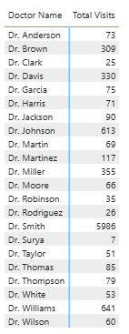
- General Practice → 7240 visits (extremely high)
- Orthopedics → 995 (moderate)
- All other departments → very low
Strong imbalance — General Practice handles majority of patients

2. Waiting Time Analysis
- Neurology → 36.80 (highest)
- Physiotherapy → 36.57
- Gastroenterology → 35.83
- Others around ~35
Neurology and Physiotherapy show highest operational pressure

3. Satisfaction Analysis
- Lowest satisfaction → Renal (4.88)
- Orthopedics → 4.96 (low)
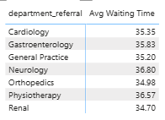
- Highest → Gastroenterology (5.94)
Some departments show experience issues despite lower load

4. Doctor Workload Analysis
- Dr. Smith → ~6000 visits (extreme overload)
- Next highest doctors → ~600–700 visits
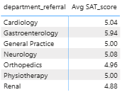
Severe workload imbalance across doctors

5. Combined Insight (Critical View)
- General Practice
  - Very high visits
  - Normal wait (~35)
  - Indicates hidden overload managed by limited doctors
- Neurology

  - Low visits but highest wait time
  - Indicates capacity shortage
- Physiotherapy
  - Moderate visits but high wait
  - Efficiency issue

Conclusion / Recommendation
- Hire 2 Doctors in General Practice
- Handles ~80% of total visits
- Severe workload imbalance (Dr. Smith overload)
- Critical for overall hospital flow

- Hire 1 Doctor in Neurology
- Highest waiting time
- Indicates insufficient staffing despite lower volume
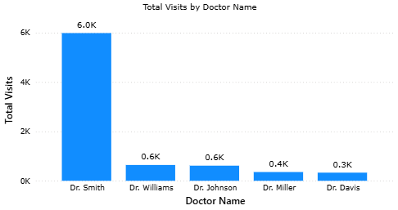
- Optional Consideration
- Monitor Physiotherapy / Orthopedics for future hiring if wait time or satisfaction worsens.

Final Recommendation
- General Practice → 2 hires (high priority)
- Neurology → 1 hire (capacity gap)

Business Justification
This decision ensures:
- Reduced patient waiting time
- Balanced doctor workload
- Improved patient satisfaction
- Better overall hospital efficiency

- Is the hospital profitable? How will you determine the profitability?
Ans: The objective is to determine whether the hospital is profitable. Since cost-related data (such as salaries, operational expenses, infrastructure costs) is not available in the dataset, profitability cannot be calculated directly using profit formulas. Therefore, profitability is assessed indirectly by analyzing revenue strength, revenue distribution, trends over time, and efficiency of revenue generation. These parameters collectively indicate whether the hospital is financially sustainable and likely profitable.

Steps (Visualizations Used and Rationale)

1. Total Revenue (KPI Card)
- Field: Total Bill (SUM)

Reason:
Total revenue represents the primary income source of the hospital. A high and consistent total revenue is the first indicator of financial strength and potential profitability.

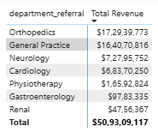
2. Revenue by Department (Table / Column Chart)

- Axis/Rows: department_referral
- Values: Total Bill (SUM)

Reason:
Analyzing revenue at the department level helps identify which departments are contributing most to the hospital’s income. This is important to understand whether revenue is diversified or concentrated in a few areas, which directly impacts financial stability.

3. Revenue Trend Over Time (Line Chart)
- Axis: Month-Year
- Values: Total Bill (SUM)

Reason:
Profitability is not only about current revenue but also about sustainability. A time-based trend helps determine whether revenue is increasing, stable, or declining. A declining trend may indicate future profitability risks.
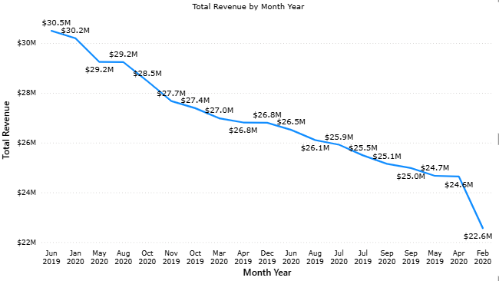

4. Revenue Contribution by Doctors (Pie Chart – Top 5)
- Legend: Doctor Name
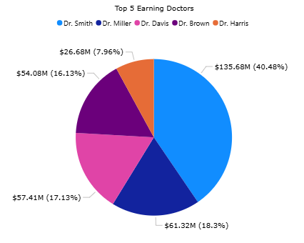
- Values: Total Bill (SUM)

Reason:
This analysis identifies whether revenue is dependent on a few key individuals. High dependency increases business risk and can affect long-term profitability if those resources are unavailable.

5. Revenue per Patient (Measure)
- Type: Measure
- Table: Doctor-Patients Data

Revenue per Patient =
DIVIDE(
SUM('Doctor-Patients Data'[Total Bill]),
DISTINCTCOUNT('Doctor-Patients Data'[patient_id])
)

Reason:
This metric evaluates how efficiently the hospital generates revenue from each patient. It helps determine whether the hospital relies on high patient volume or high-value services, which is essential for understanding the nature of profitability.

Insights / Observations
- The hospital generates a high total revenue (approximately $509M), indicating strong income generation.
- Revenue is concentrated in a few departments, particularly General Practice and Orthopedics.
- The revenue trend shows a gradual decline over time, which may pose a risk to future profitability.
- A significant portion of revenue is generated by a small number of doctors, indicating dependency.
- Revenue per patient appears relatively consistent, suggesting a volume-driven revenue model.

Conclusion & Recommendation
The hospital demonstrates strong revenue generation and operational activity, which indicates that it is likely profitable. However, profitability cannot be confirmed definitively due to the absence of cost data.
From the analysis, it can be concluded that:
- The hospital’s financial performance is currently strong.
- However, declining revenue trends and dependency on key doctors present potential risks to sustained profitability.
To strengthen profitability, the hospital should:
- Improve patient inflow and retention to counter declining trends.
- Reduce dependency on individual doctors by balancing workload and hiring strategically.
- Optimize operations to maintain efficiency and service quality.
Thus, while the hospital appears financially viable, long-term profitability will depend on addressing these operational and strategic factors.

- Any Department for which the waiting time is oddly large?
Ans: Approach
Identify departments with unusually high waiting times by comparing average waiting time across departments, and validating it with patient volume and satisfaction to determine whether the delay is justified (high demand) or inefficient (low capacity).

Steps (Visualizations Used and Rationale)
1. Multi-Metric Department Matrix (Primary Visual)

- Rows → department_referral
- Values →
  - Average Waiting Time
  - Total Visits
  - Average Patient SAT

Reason:
This combined view allows simultaneous evaluation of:
- Operational pressure (wait time)
- Demand (visits)
- Service quality (satisfaction)
This helps distinguish whether high waiting time is due to high demand or inefficiency.

2. Supporting Combo Chart (Validation)
- X → department_referral
- Column → Total Visits
- Line → Average Waiting Time

Reason:
To visually compare demand vs waiting time and quickly identify departments where waiting time is disproportionately high relative to patient volume.
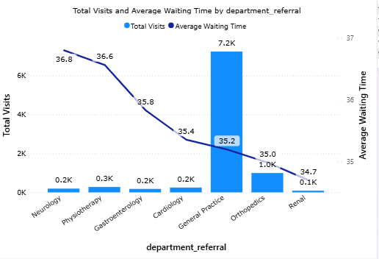

Insights / Observations
- Neurology has the highest waiting time (~36.80 mins) despite relatively low patient volume (~193 visits)
- Physiotherapy (~36.57 mins) also shows high waiting time with moderate demand
- Gastroenterology (~35.83 mins) shows slightly elevated waiting time but not extreme
- General Practice, despite extremely high visits (~7240), maintains a moderate waiting time (~35.20 mins)
→ Indicates better handling of high demand

Conclusion

The waiting time is oddly large in Neurology, as it has the highest delay despite low patient volume, indicating a capacity or resource constraint rather than demand pressure.
Physiotherapy also shows signs of inefficiency due to relatively high waiting time compared to its workload.

Recommendation:
- Prioritize Neurology for operational improvement or additional staffing
- Monitor Physiotherapy for potential inefficiencies
- General Practice does not require immediate intervention for waiting time despite high demand

This analysis ensures that decisions are based not just on high values, but on contextual imbalance between demand and service capacity, which is critical for operational optimization.

- Come up with strategies to provide discounts to the patients.
Ans: Approach
The objective is to design a comprehensive discount strategy that balances patient acquisition, retention, and revenue optimization. Since repeat-visit data is not available, the strategy is based on patient spending patterns, departmental performance, and demand trends, along with industry-standard practices.

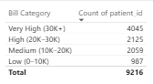
Steps
1. Billing Category Analysis
- Visual: Column Chart
- X → Bill Category
- Y → Count of patient_id

Reason:
To identify distribution of patients across spending levels and define discount tiers based on patient value.

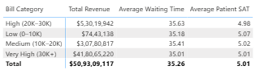
2. Multi-Metric Matrix
- Rows → Bill Category
- Values →
  - Total Revenue (measure)
  - Average Waiting Time (measure)
  - Average Patient SAT (measure)

Reason:
To evaluate whether discounts should be based on experience or value.
Observation shows minimal variation in experience → discounts should focus on billing value.

3. Revenue by Department
- Visual: Column Chart
- X → department_referral
- Y → Total Revenue (measure)
Reason:
To identify high-revenue departments and support department-specific offers and bundled services.



4. Monthly Demand Trend
- Visual: Column Chart
- X → Calendar[Month Year]
- Y → Total Visits (measure)
Reason:
To identify fluctuations in demand and support seasonal or off-peak discount strategies.

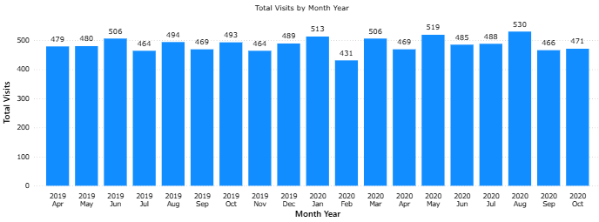

Insights / Observations
- Majority of patients fall in medium to high billing categories (10K–30K range)
- Revenue is concentrated in high and very high billing groups
- Patient experience (waiting time & satisfaction) is relatively consistent across billing categories
- Revenue is dominated by General Practice and Orthopedics departments
- Monthly visits show fluctuations with a slight declining tendency, indicating scope for demand stimulation

Proposed Discount Strategies

1. Tier-Based Discounts (Data-Driven)
- Low Value (<10K) → 5% discount
- Medium Value (10K–30K) → 7% discount
- High Value (>30K) → 10% discount
Justification:
Encourages higher spending while protecting revenue from unnecessary discounting.

2. Department-Based Bundled Offers
- Offer package discounts in high-revenue departments (e.g., General Practice, Orthopedics)
- Combine multiple services at a reduced price
Justification:
Increases overall billing per patient and promotes service utilization.

3. Seasonal / Off-Peak Discounts
- Introduce promotional offers during months with lower patient visits
Justification:
Helps stabilize demand and improve resource utilization.

4. New Patient Acquisition Offers
- Provide first-visit discounts or consultation fee waivers
Justification:
Encourages new patient onboarding and expands patient base.

5. Membership / Loyalty Programs (Conceptual)
- Annual membership with benefits such as discounted services and free checkups
Justification:
Although repeat visit data is not available, such programs are industry-standard for improving long-term engagement.

6. Targeted Community Discounts
- Discounts for senior citizens, students, or community groups
Justification:
Enhances accessibility and builds goodwill without major revenue impact.

Conclusion
The proposed discount strategy is multi-dimensional and balanced, combining data-driven insights (billing, department, demand trends) with business-oriented initiatives (membership, seasonal offers, acquisition strategies).
This ensures:
- Increased patient inflow
- Improved revenue per patient
- Better utilization of hospital resources
- Long-term patient engagement
Overall, the strategy moves beyond simple discounting and aligns financial decisions with operational efficiency and growth objectives.

- Say you need to align the doctors of the “General Practice” department to work in one of the two shifts, how will you identify what will these two shifts' timings be, and how will you divide the doctors in these two shifts? And also will this 2-shift policy be helpful for the hospital?
Ans: Approach
The objective is to determine optimal doctor shift timings and allocation by analyzing hourly patient demand, waiting time patterns, departmental workload, and doctor-level utilization. The goal is to align staffing with demand to reduce waiting time and improve efficiency.

Steps (Visualizations Used and Rationale)
1. Hourly Patient Volume Analysis
- X-axis: Hour
- Y-axis: Total Visits (measure)
Purpose:
To identify peak and low demand periods and understand how patient inflow varies throughout the day.

2. Hourly Waiting Time Analysis
- X-axis: Hour
- Y-axis: Average Waiting Time (measure)
Purpose:
To identify hours where system pressure is high and validate whether resource allocation matches demand.
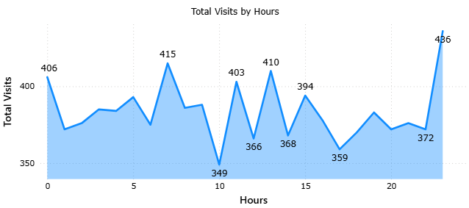

3. Department-wise Hourly Load (Matrix with Conditional Formatting)
- Rows: Hour
- Columns: Department
- Values: Total Visits
Purpose:
To determine which departments are contributing most to the workload at different times of the day.
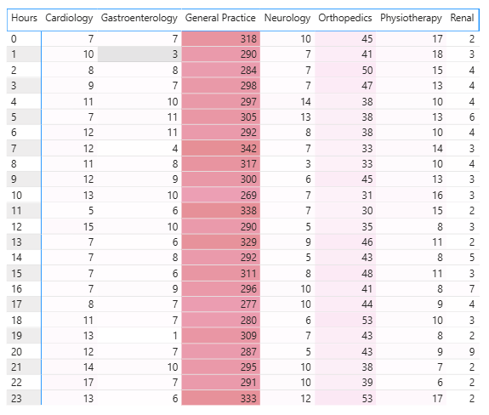

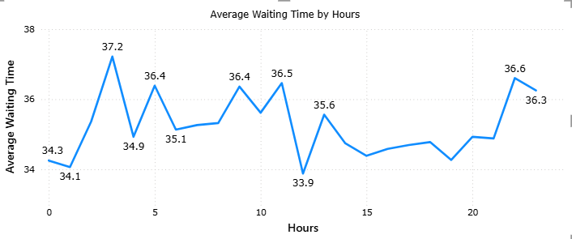


4. Doctor-wise Workload Distribution
- Rows: Doctor Name
- Values: Total Visits
Purpose:
To identify imbalance in workload distribution and support better allocation across shifts.

Insights / Observations
1. Demand Distribution Across Hours
- Multiple demand peaks are observed rather than a single concentrated peak.
- Significant patient inflow occurs during early morning (around Hour 7) and mid-day (around Hour 13).
- The highest spike is observed at late-night (Hour 23).
- The lowest demand occurs around Hour 10.
This indicates that hospital demand is spread across the day and requires continuous staffing rather than a single heavy shift.

2. Waiting Time Patterns
- Waiting time peaks at specific hours (e.g., Hour 3, Hour 11, Hour 22).
- The lowest waiting time is observed around Hour 12.
Since waiting time does not strictly follow patient volume, it suggests inefficiencies in staffing during certain hours, reinforcing the need for structured shift allocation.

3. Department-wise Workload
- General Practice consistently handles the majority of patient volume across all hours.
- Other departments contribute comparatively less but still require support during peak periods.
This implies that staffing decisions should prioritize General Practice across both shifts.

4. Doctor Workload Imbalance
- A small number of doctors handle a disproportionately high number of patients.
- Several doctors remain underutilized.
This imbalance highlights the need for redistribution of workload through structured shift allocation.

Shift Design with Justification
Shift 1: 6:00 AM – 2:00 PM
Reasoning:
- This shift covers the early morning rise in patient inflow, including the first major peak around Hour 7.
- It also includes the mid-day demand period, where patient volume remains consistently high.
- Since patient inflow starts increasing early and sustains until mid-day, this shift ensures that sufficient doctors are available during the most operationally intensive period.
How it helps:
- Reduces congestion during the morning peak
- Improves patient flow during high-demand hours
- Ensures timely handling of cases when inflow is highest

Shift 2: 2:00 PM – 10:00 PM
Reasoning:
- This shift captures the afternoon and evening patient flow, which, although slightly lower than morning peaks, remains significant.
- It also supports the system during late-evening hours where waiting time tends to increase, indicating operational strain.
How it helps:
- Maintains service continuity after the primary peak
- Prevents build-up of waiting time in the second half of the day
- Ensures balanced workload distribution across the day

Additional Consideration: Late-Night Coverage
Observation:
- A noticeable spike in patient visits occurs at Hour 23 (late night).
Implication:
- The two standard shifts may not fully cover this surge.
Recommendation:
- Introduce a rotational or partial night shift
OR
- Extend coverage for a subset of doctors into late-night hours
How it helps:
- Prevents overload during late-night spikes
- Ensures patient service continuity beyond standard hours

Doctor Allocation Strategy
- Allocate more doctors, particularly from General Practice, to Shift 1 to manage peak demand.
- Distribute doctors more evenly in Shift 2 to handle steady demand and reduce waiting time.
- Reassign workload from highly burdened doctors to underutilized ones to improve efficiency.

Evaluation of 2-Shift Policy
The two-shift system is effective because:
- Patient demand is distributed across multiple time periods rather than concentrated in one block.
- Waiting time variations indicate that current staffing does not align well with demand.
- Doctor workload imbalance suggests inefficiencies in allocation.
A structured shift system aligns resources with demand, improves utilization, and reduces waiting time.

Conclusion
A two-shift system, supported by targeted late-night coverage, is appropriate for the hospital. The chosen timings are directly aligned with observed patient demand patterns and operational pressure points. When combined with proper doctor allocation, this approach ensures improved efficiency, reduced waiting time, and better overall patient service.

- What do you understand by Power BI gateway? What are its use cases?

Ans: Power BI Gateway
Power BI Gateway is a secure bridge that enables data transfer between on-premises data sources (such as local databases, Excel files, or servers) and Power BI Service (cloud).
Since Power BI Service operates in the cloud, it cannot directly access data stored within an organization’s internal network. The gateway solves this problem by allowing secure, controlled communication between the two environments.

- Types of Power BI Gateway

1. Personal Mode Gateway
- Designed for individual use
- Used mainly for scheduled data refresh
- Cannot be shared with other users
- Suitable for small-scale or personal projects

2. Standard (Enterprise) Mode Gateway
- Designed for organizational use
- Can be shared across multiple users and reports
- Supports both:
  - Scheduled refresh
  - Live/DirectQuery connections
- Centrally managed by administrators

- Use Cases of Power BI Gateway

1. Scheduled Data Refresh
- Automatically refresh reports using on-premises data
- Example: Daily refresh of hospital patient records stored in a local SQL database
Benefit:
Ensures reports always display up-to-date information without manual intervention.

2. Real-Time / Live Data Access (DirectQuery)
- Allows Power BI to query on-premises data sources in real time
Benefit:
Provides up-to-date insights without storing data in the cloud.

3. Secure Data Access
- Maintains security by keeping data within the organization’s network
- Only query results are transmitted, not the entire dataset
Benefit:
Ensures compliance with data governance and privacy policies.

4. Integration with Other Microsoft Services
- Enables cloud services such as:
  - Power Apps
  - Power Automate
  - Azure Analysis Services
to access on-premises data
Benefit:
Supports end-to-end business solutions and automation workflows.

5. Centralized Data Management (Enterprise Gateway)
- Allows multiple reports and users to connect through a single gateway
Benefit:
Simplifies administration and improves scalability in large organizations.

- Conclusion
Power BI Gateway plays a critical role in enabling seamless and secure integration between on-premises data and cloud-based analytics. It ensures that organizations can leverage Power BI Service while maintaining control over their internal data systems, supporting both real-time access and automated data refresh capabilities.

- How would you approach this problem, if the objective and subjective questions weren't given?
Ans: Approach
In the absence of predefined questions, the analysis would follow a structured, exploratory, and hypothesis-driven approach. The goal would be to understand the dataset, identify key business problems, and derive actionable insights that support decision-making for hospital management.

Step 1: Data Understanding and Preparation
- Review all available tables (e.g., Hospital ER, Doctor-Patients Data, Calendar)
- Understand key fields such as patient demographics, department referrals, waiting time, satisfaction scores, and billing information
- Check for:
  - Missing values
  - Inconsistent formats
  - Incorrect data types
- Establish relationships between tables (e.g., patient_id, date fields)
Purpose:
To ensure data quality and build a reliable foundation for analysis.

Step 2: Define Key Performance Indicators (KPIs)
Based on the hospital context, define core metrics such as:
- Total Visits
- Average Waiting Time
- Average Patient Satisfaction Score
- Total Revenue
- Revenue per Patient
- Department-wise performance
Purpose:
To create measurable indicators that reflect operational efficiency and business performance.

Step 3: Exploratory Data Analysis (EDA)
Conduct broad analysis to uncover patterns and trends:
a. Time-Based Analysis
- Patient visits by month, year, and hour
- Identification of peak periods and seasonality
b. Demographic Analysis
- Patient distribution by age, gender, and race
- Impact of demographics on visits and satisfaction
c. Department Analysis
- Visits, revenue, and waiting time across departments
- Identification of high-performing and underperforming units
d. Experience Analysis
- Relationship between waiting time and satisfaction
- Identification of service gaps
Purpose:
To generate initial insights and identify potential problem areas.

Step 4: Identify Key Business Problems
From exploratory analysis, derive core problem statements such as:
- High waiting time in specific departments or time periods
- Uneven doctor workload distribution
- Declining patient visits over time
- Revenue concentration in limited departments
- Variations in patient satisfaction
Purpose:
To convert observations into actionable business questions.

Step 5: Deep-Dive Analysis
Perform targeted analysis for each identified problem:
- Analyze root causes of high waiting time
- Evaluate doctor performance and workload distribution
- Study revenue drivers and patient spending patterns
- Assess demand patterns for resource planning
Purpose:
To move from descriptive insights to diagnostic insights.

Step 6: Build Visualizations and Dashboard
Create an interactive dashboard with:
- KPI cards for quick overview
- Trend charts (time-based analysis)
- Heatmaps (hour vs department load)
- Distribution charts (demographics, billing categories)
- Comparative charts (department and doctor performance)
Purpose:
To present insights in a clear, accessible, and decision-friendly format.

Step 7: Derive Insights and Recommendations
Translate analysis into actionable strategies:
- Optimize doctor shift planning
- Introduce targeted discount strategies
- Improve resource allocation in high-demand departments
- Reduce waiting time through better scheduling
- Enhance patient satisfaction through operational improvements
Purpose:
To ensure the analysis contributes directly to business decisions.

Conclusion
In the absence of predefined questions, a structured exploratory approach allows for systematic discovery of insights. By combining data understanding, KPI definition, exploratory analysis, and focused problem-solving, it is possible to identify key operational and strategic opportunities, ultimately enabling data-driven decision-making for the hospital.

- Can you analyze and write the type of relationship between the doctor id and department, is it one-to-one?
Ans: Approach

To determine the relationship, the mapping was analyzed in two directions:
- Doctor → Department
- Department → Doctor
This ensures clarity on whether the relationship is one-to-one, one-to-many, or many-to-many.
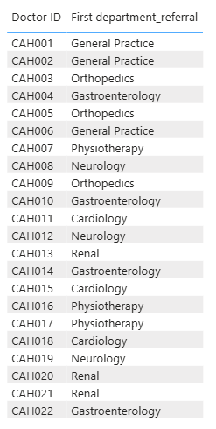
Steps (Visuals Used and Rationale)

1. Doctor to Department Mapping
- Rows → Doctor ID
- Values → department_referral
Purpose:
To verify whether each doctor is associated with a single or multiple departments.

2. Department to Doctor Mapping
- Rows → department_referral
- Values → Doctor ID
Purpose:
To check how many doctors are associated with each department.

Insights / Observations

1. Doctor-Level Observation
- Each Doctor ID appears only once and is linked to a single department
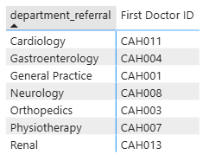
- No doctor is associated with multiple departments

2. Department-Level Observation
- Each department has multiple doctors
  - Example: General Practice, Orthopedics, Neurology, etc. all have several doctors

Conclusion:

The relationship between Doctor ID and Department is One-to-Many:
- One Department → Many Doctors
- One Doctor → One Department
This confirms that:
- It is not a one-to-one relationship
- It is also not many-to-many, since doctors are not linked to multiple departments

Implication:
- Department-level metrics (e.g., total visits, revenue) correctly aggregate multiple doctors
- Doctor-level analysis remains independent within each department
- This structure supports efficient resource allocation and department-wise performance evaluation

This measure was used in a chart with Department Referral on the axis to visualize the total visits for each department.

DASHBOARDS OVERVIEW
